CURRICULUM VITAE
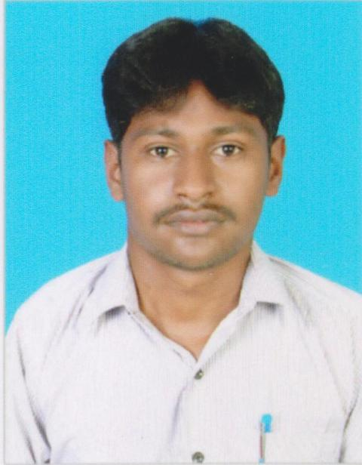

B.VEERAKUMAR. M.Sc. (Agri)
No.33, Karunanithi Nagar,
3rd Street,
New Market East,
Karaikudi,
Sivagangai DT.
Pin: 630 001. Mobile No: 9750077868, 9445862672
E-mail: vimstoy@gmail.com
CAREER OBJECTIVES
A challenging position that utilizes my skills for enhancement of organization’s performance and to develop my skills further.
EDUCATIONAL QUALIFICATION
Examination | Institution | Year of Passing | % of marks
S.S.L.C | SMSV Higher Secondary School, Karaikudi | 2004-2005 | 58%
H.Sc. | Govt. Higher Secondary  School, Ariyakudi. | 2006-2007 | 77%
BSc. (Agri) | Annamalai University,  Annamalai Nagar. | 2007-2011 | 76%
Tally9 | CSC Computer, Chidambaram. | 2011 | 99%
MSc. (Agri)  Agronomy | Annamalai University,  Annamalai Nagar. | 2011-2013 | 86%
MSc. (Agri)
Title of the thesis | Year completed | University
IMPROVED RICE CROP MANAGEMENT FOR RAISING PRODUCTIVITY IN SUBMERGENCE PRONE RAINFED LOWLANDS IN SOUTH ASIA | 2011-2013 | Department of Agronomy Faculty of Agriculture, Annamalai University,  Annamalai Nagar.

Experience of the work
designation | Institution | Year of working | Experience
Zonal in-charge | Padmaadevi sugars ltd  Formally Sv. Sugar mill pvt  Kancheepuram | August  2013/till now | Doing job two Year’s & 5 month experience.  Current Salary-20000  Expectation salary-32000  Notice period-15 days

JOB ROLL
- Zonal in charge
- Team leader
- Immediately reporting officer
- Guide to field officers
- Improved the cane areas more than 50% production & productivity
- Good Chemical recommendation for all crops
- Improved the agronomic technologies in sugarcane crop
- To maintaining the all record books, develop division office,
- Conducted staff meeting, several village meetings & Demo
TRAINING ATTEND
- Workshop on Entrepreneurship Development Programme @ Annamalai University.
- RAWE (Rural Agriculture Work Experience)
- Disaster Risk Reduction Management Training Programme
- Demonstration Programme on IPM methods
COMPUTER KNOWLEDGE:
- M.S. Office
- Bio Informatics
EXTRA CURRICULAM ACTIVITIES
- NSS
- Competition
- FOOD BALL
SOFT SKILLS AND ATTRIBUTES:
- A good team member and careful listener
- Ability to adapt to new environments at a faster pace.
- Ability to make right decision at right times.
- Keen interest in sharing knowledge and experience.
PERSONAL DETAILS
Name : B.VEERAKUMAR
Father’s Name : Mr. K. Balamurugan
Date of Birth : 09.06.1989
Gender : Male
Nationality : Indian
Religion : Hindu
Marital Status : Single
Languages Known : Tamil & English
DECLARATION
I hereby declare that the statements furnished above are true, correct and complete to the best of my knowledge and belief.
Place: Karaikudi Yours Faithfully

Date:26.1.2016 (B.VEERAKUMAR)

